Honored colleague;

We’re writing to request your cooperation in fulfilling the internship requirements of Bahçeşehir University Faculty of Pharmacy students. Per Turkish Council of Higher Education guidelines, the PHARM3999: Internship I class requires each student to intern in an active pharmacy for a minimum of thirty working days. We would like to thank you for providing this opportunity for our students, as well as your support and assistance to our faculty.
We’d like to inform you that our students are insured during workdays (and workdays only) within their internship period, and that they are required to be physically present in the pharmacy during this time. We ask you to please plan the internship according to the guidelines provided below and, should you deem it adequate, stamp and sign the report prepared by the intern at the end of the internship period (note that each page must be stamped and signed). In addition, please complete the Internship Evaluation Form, seal it in a stamped and signed envelope, and return it to the intern for delivery to our department.
We thank you for your assistance to us and our students, and wish you success in your work.

Addendum 1. Internship learning benchmarks.
Addendum 2. Internship Evaluation Report.

Bahçeşehir University
Faculty of Pharmacy
Internship Commission

Addendum 1. Internship learning benchmarks.
Class: PHARM3999 INTERNSHIP 1
Internship category: Independent pharmacies.
- Definitions
  - Definition of pharmacy
  - Definition of a pharmacist
- General information concerning the interned pharmacy
  - Building requirements and procedures for opening a pharmacy
  - Duties and responsibilities of independent pharmacists as healthcare workers
  - Definitions, duties, powers and responsibilities of auxiliary personnel working at a pharmacy
  - Organization of a pharmacy, rules for the categorization and placement of drugs and other pharmaceutical goods
  - Shelf organization systems (alphabetical, pharmaceutical relevance etc.)
  - Tools and equipment used in the operation of a pharmacy
  - Work hours of a pharmacy, the concept of late-night pharmacies and the system by which pharmacies are assigned to late-night duty.
- Purchase and acquisition procedures for drugs, cosmetics and medical supplies
  - Duties and responsibilities of pharmacists
  - Duties of auxiliary personnel in purchase decisions
  - Pharmacist-pharmaceutical warehouse interactions, inspection and registration of purchased goods, payment conditions
- Matters of import in pharmacist-patient interactions
  - General aspects of patient interactions
  - Systematic approaches to answering patient questions
  - Patient education techniques (health education, drug literacy etc.)
  - Frequently asked questions for pharmacists
  - Approaches for patients presenting with acute disease
  - Approaches for patients presenting with chronic disease
- Prescription filling procedures
  - Terms used in prescriptions
  - ICD-10 and diagnostic report codes in prescriptions
  - Matters of import regarding prescription filling
  - Prescription logbooks and the prescription logging process
- Computers and software use in pharmacies (You can explain the programs that are also used in your country.)
  - Turkish Social Security Service (Sosyal Güvenlik Kurumu, SGK) provision system (MEDULA) and relevant pharmaceutical software (TEBEOS, Farmakom etc.)
  - Turkish Medical Enforcement Declaration (Sağlık Uygulama Tebliği, SUT) and electronic pharmaceutical information resources (Rx Media etc.)
  - The Turkish Pharmaceutical Track and Trace System (İlaç Takip Sistemi, İTS)
  - Available stocks and expiration dates of pharmaceutical and medical materials, disposal of soon-to-expire pharmaceuticals
  - Income and expense balance, profits, differences in purchase and sales across fiscal periods
  - Profiling of pharmaceuticals in the context of the Turkish Personal Data Protection Law (Kişisel Verilerin Korunması Kanunu, KVKK)
- Pharmaceuticals that must be present in the pharmacy
- Use of fridges, pharmaceuticals requiring cold storage
- Tracking of temperature and humidity in pharmacies
- Procedures regarding the calibration and inspection of fridges, thermometers, hydrometers, scales and other measurement devices
- Organization of the pharmacy’s laboratory and the materials and equipment it must contain.

Addendum 2
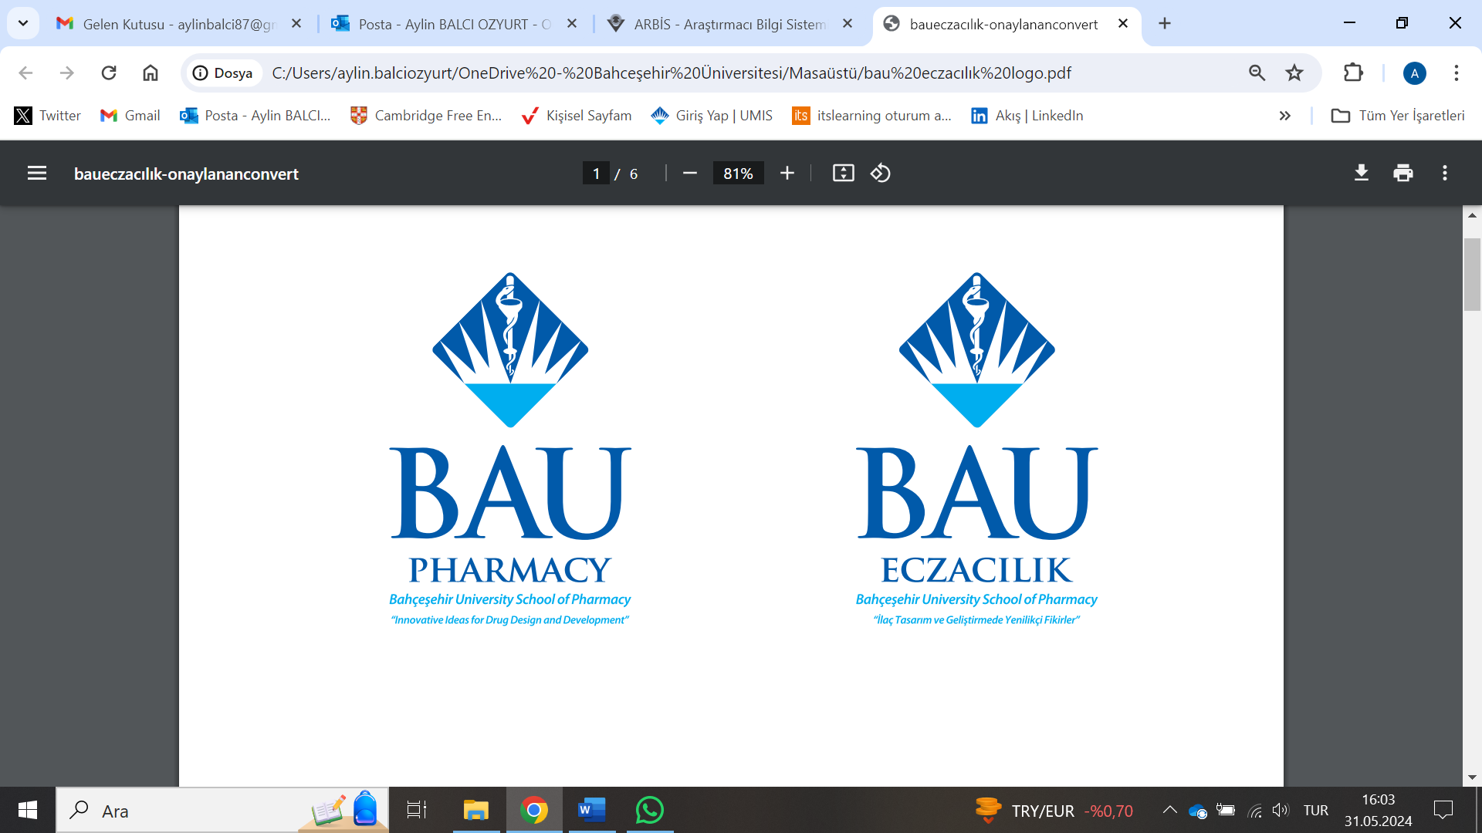 | T.C. BAHÇEŞEHİR UNIVERSITY  SCHOOL OF PHARMACY  INTERNSHIP EVALUATION REPORT

. Student and internship information
Student no:
Name:
Contact information for interned pharmacy:
Phone/Address:
Internship start date:
Internship end date:

- Internship evaluation
 | 20 points inadequate | 40 points below average | 60 points average | 80 points  above average | 100 points excellent
Daily attendance | ▪ | ▪ | ▪ | ▪ | ▪
Punctuality regarding work times | ▪ | ▪ | ▪ | ▪ | ▪
Obedience to work rules | ▪ | ▪ | ▪ | ▪ | ▪
Interactions with patients/customers | ▪ | ▪ | ▪ | ▪ | ▪
Ability to communicate and work in a group | ▪ | ▪ | ▪ | ▪ | ▪
Desire for improving professional knowledge and skill | ▪ | ▪ | ▪ | ▪ | ▪
Desire for self-improvement | ▪ | ▪ | ▪ | ▪ | ▪
Sense of duty | ▪ | ▪ | ▪ | ▪ | ▪
Professional skill | ▪ | ▪ | ▪ | ▪ | ▪

Other observation and suggestions

Overall evaluation of the intern
Success evaluation: | ( ) Successful ( ) Unsuccessful
Date of evaluation:

Supervising pharmacist’s
Name Stamp and signature
* To be delivered to the office of the dean in a sealed envelope after signing and stamping.

